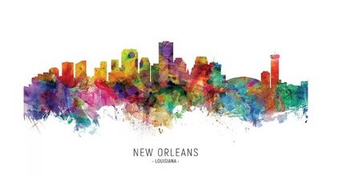
Welcome, friends…

So much food and music, so many fun things to do
and gorgeous sights to see in this town…so little time.

Birthday headquarters: Treme Blue House, 1210 N. Galvez
Any questions about anything, don’t hesitate to call or text Patti - 510.407.9174
Important: masks and proof of vaccines are needed at all bars & restaurants, music venues & museums.
For the health and welfare of all our guests, visitors and the world,
we kindly ask you test negative for Covid-19, at the most, 72 hours before you travel to New Orleans.

Here is a list of planned events for April 10 – 15.
Events in GREEN indicate birthday celebrations we hope you’ll attend as our guests.
PLEASE, NO PRESENTS. YOU ARE THE GIFT!
All other events are absolutely optional and at your discretion.
Also listed are additional recommended things to do and sights to see while you’re
out and about on your own.
Please RSVP by email by March 1st. In order to keep a general headcount for reservations, etc.
please let us know all the events you plan to attend: pacary13@gmail.com

Latest revisions/additions will be in GREEN
Events may be subject to change, so…
CHECK BACK HERE OFTEN FOR MORE INFO, MORE EVENTS, CHANGES & UPDATES.
If your plans change, no prob, just let us know.

Monday, April 11:

9am – Breakfast & Tour
Degas House, 2306 Esplanade, Treme
Rise early and enjoy an authentic Creole breakfast, followed by an award-winning guided, Edgar Degas House Creole Impressionist Tour. Note: there are no original paintings and sculptures by Edgar Degas in the home. Degas House itself is the artifact! Info $50

7pm - Dinner
Sylvain’s, 625 Chartres St. (patio), French Quarter
Set in a carriage house built in the late 1700s and named after the first opera to be performed in New Orleans in 1796, this unruly, Southern bistro is a hangout for locals and features some of the best cocktails in the city. Menu $$

9pm – Dark History Tour
Jonathan Weiss Tours, 622 Pirate’s Alley, French Quarter
Ghosts, legends and true crime! Join us for a private walking tour through the historic French Quarter with local raconteur extraordinaire, Jonathan Weiss. Disclaimer: tour is equal parts history, entertainment, and horror. Wear comfy shoes. $25

Tuesday, April 12:
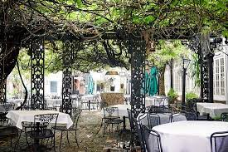
10am – Brunch
Court of Two Sisters, 613 Royal St., French Quarter
Built in 1832, this Creole landmark boasts the largest courtyard in the city. The restaurant is named for the two sisters whose downstairs shop outfitted many of the city’s finest women with Mardi Gras costumes and offered perfumes from Paris. The front gates were wrought in Spain especially for the restaurant and legend has it that Queen Isabella had them blessed so that their charm would pass on to anyone who touched them. Oh, yeah…come hungry. The buffet is amazing. Menu $33/per person

4:00-4:45pm – Test Porch Pre-party
Treme Blue House, 1210 N. Galvez
For the safety of all our guests, you’ll need a negative Covid-19 antigen rapid test (test provided + one adult beverage) before entering the Treme Blue House (birthday headquarters). No exceptions. We hope you understand and appreciate these extra precautions.

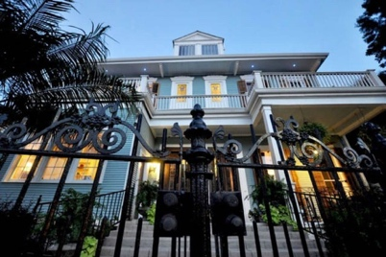
5:00pm – Presentation: Welcome to New Orleans!
Treme Blue House, 1210 N. Galvez
Arthur Morgan Smith, former Communications Director at the Louisiana State Museum, tour guide and volunteer for Save Our Cemeteries and Friends of the Cabildo, will give a fun and informative presentation on the history and culture of this amazing city and is happy to answer any questions you may have. Don’t miss it!

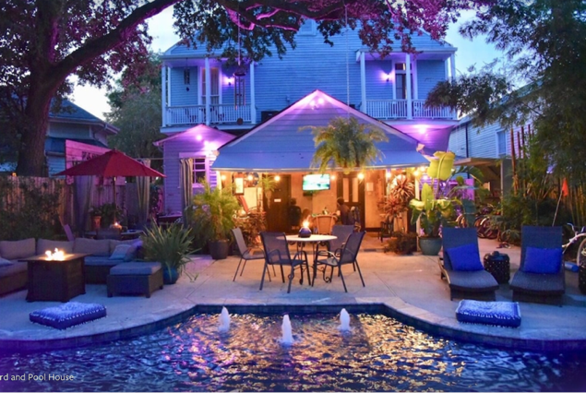
6pm - Patti’s Pool Party Pre-Party
Treme Blue House, 1210 N. Galvez
Bring your swimsuit and dancing shoes and hang out at birthday headquarters for some great music, food, drink and general hoopla!! Come hungry and enjoy a delicious spread from Willie Mae’s, including what is widely considered the best fried chicken in NOLA. Brave souls can stick around for…
9pm - Ghost Stories by the Fire
Hosted by local legend, Bloody Mary of

Wednesday, April 13 (NONOTSIXTY!?!)

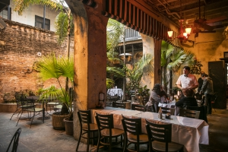
6:30PM – Creole Nibbles, Cake & Cocktails
Napoleon House (bar/restaurant), 500 Charters (x. St. Louis)
This two-hundred-year-old landmark was intended to be used by the original owner to shelter the exiled Napoleon and Josephine, but alas, the Emperor never made it to the New World. European ambience, signature Pimm’s Cups and Muffaletta sandwiches – an homage to the Italian immigrants who first opened grocery and deli stores along the riverfront of the French Market.
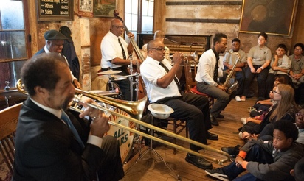
8:15PM (sharp!)– Preservation Hall Jazz Band
Preservation Hall, 726 St. Peters, French Quarter
Originally opened in the 1950s as an art gallery, this intimate, funky venue presents acoustic New Orleans Jazz concerts featuring ensembles from a current collective of 50+ local master players. On any given night, audiences bear joyful witness to the evolution of this venerable and living tradition. Put some $$ in the tip jar and make a request!

9:30pm – Nocturnal Nightcap
Vampire Café, 801 Royal St., French Quarter
Mere steps from Preservation Hall, top off the evening with a Dracula Sparkling Bellini or maybe a glass of Trueblood Cabernet or… maybe just a little…bite?! Sorry.
Thursday, April 14

10AM til 1PM – Cooking Class + lunch
New Orleans School of Cooking – 524 St. Louis, French Quarter

This class is hands-on with a limit of 10 per class, so it’s first ticket purchase, first serve. Menu: Tasso and Sweet Potato Bisque, Beef Grillades and Grits (g-r-i-t-s), Bananas foster + Bloody Mary bar, Dixie Beer and wine = $145. Vegan & gluten-free substitutions available for an extra $10.

Friday, April 15

7:00PM – Farewell Dinner
Dooky Chase’s, 2301 Orleans Ave., Treme (10 min walk from birthday headquarters)
What better place to draw our week to a celebratory close? This historic, family-owned Creole hot spot has served as the meeting place for politicians, activists, and culture bearers in New Orleans since 1941. Menu $$

So much more to see & do…
(best to make sure this info is still up-to-date before you head out)
Important: masks and proof of vaccines are needed at all bars & restaurants, music venues & museums.

The Poop on Bourbon Street

As you most likely know, the reputation of Bourbon Street mainly
revolves around garish trinket shops and drunk, unruly college kids and convention-goers getting their ya-yas out, hoping to catch a glimpse of some nakedness. For these reasons (and possibly more) you might want to avoid Rue Bourbon at all costs. That said, there are actually a few places on the crowded, rowdy row that are really worth checking out.

Old Absinthe House, #240 – cross street Bienville
Open seven days a week – generally from 9am til 2am (4am on Sundays!)
This iconic corner spot is perfect for grabbing a stool, sitting back and watching the wild and whacky show that is Bourbon Street go by. Marvel at the shenanigans while you sip on a refreshment, perhaps their signature Absinthe Frappe, in this cool building that dates back to the early 1800s.

Oz New Orleans, #800 – cross street St. Ann
Open 6pm til ?
Infamous, late-night gay dance club with DJs, drag shows, go-go dancers & a balcony for people-watching. Not for the faint of heart.

Fritzel’s European Jazz Club, #733 – between Orleans & St. Ann
Open daily, 11am til ?
Situated in an historic 1831 building in the heart of the French Quarter, since opening in 1969, Fritzel’s has become a mecca for jazz lovers and musicians alike. Home of traditional New Orleans jazz every day and night of the week.

Clover Grill, #900 – cross street Dumaine
Open 24 hours!!
As seen in The Curious Case of Benjamin Button, this retro diner has been serving the best burgers and breakfasts on Bourbon Street since 1939. Their motto – “We love to fry and it shows.”

Lafitte’s Blacksmith Shop (bar) – #941 (see Seriously Spooky section below)
History Matters

New Orleans Jazz Museum, Old Mint Building, 400 Esplanade, French Quarter
Tues – Sun, 9am – 4PM, $8
Celebrates the history of jazz, in all its forms, through dynamic interactive exhibits, multi-generational educational programming, research facilities, and engaging musical performances. Explore America’s quintessential musical art form in the city where jazz was born.

Hermann-Grima + Gallier Historic Houses, 1132 Royal St, French Quarter
Wed – Mon, 10Am-4PM, $25 for both homes
Nothing tells a story like a home. Touring these two 19th-century homes provides an accurate and inclusive illustration of the historical fabric of New Orleans. HGGHH continually works to expand their interpretation of both houses, including the lives of the enslaved peoples, who both lived and worked there.

National WWII Museum of New Orleans, 945 Magazine St.
Open daily 9AM – 5PM
Award-winning museum featuring many special events, tours and lectures, tells the story of the American experience in the war that changed the world—why it was fought, how it was won, and what it means today—so that all generations will understand the price of freedom and be inspired by what they learn. Make a breakfast or lunch date out of it and dine at the soda shop, open 8am-3pm.

Art For All

Royal Street Stroll
Take time for a leisurely walk down the most elegant street in the French Quarter. Royal street is lined by a wide array of interesting, funky and exquisite art galleries, antique shops and a gorgeous, historic hotel. Start at the east end and work your way down towards Canal St. There are dozens places worth stopping to see. Here is just a sampling:
* An artist after my own heart - Frank Relle Photography at #910 is some of the most hauntingly gorgeous work you’ll ever see. Check out the video on his website to see how he works. Amazing.
* Stroll around Jackson Square, where artists gather to sell their wares all around the park, then pop into the Rodrigue Studio at #730 Royal to see what the famous Blue Dog has been up to.
* At #622 Royal you’ll find the world-famous M.S. Rau antique and fine art gallery, established in 1912 with 40,000-square-feet of carefully selected works from a diverse array of artists and makers who have defined the fine and decorative arts over the centuries, including Monet, Rembrandt & Chippendale, to name just a few. The collection is breathtaking.
* For fans of architecture and fashion, The Historic New Orleans Collection at #520, is a museum dedicated to the preservation of the culture of NOLA, featuring restored historic buildings and exhibits.
* Cap off your stroll with a delicious cocktail at the fun Carousel Bar inside the gorgeous Hotel Monteleone at #214. Kitschy and wonderful!

Mardi Gras World, 1380 Port of New Orleans Place
Open daily 9AM – last admission 4:30PM, $22

Yes, it’s touristy, but, if you are a maker, artist or craftsperson of any kind – you really should check out this amazing, one-of-a-kind working museum. See where and how the huge, lavish floats are made, over 500 every year, and hang out where it’s Mardi Gras every day! Learn about founder Blaine Kern and the rich history of Kern Studios that date back to 1932, when the first mule-drawn float was built on the back of a garbage wagon. This massive space is a feast for the senses. To get there, catch a free shuttle from many of the hotels on Canal St.

New Orleans Museum of Art, One Collins C. Diboll Circle, City Park
Open Tues – Sunday, 10AM – 5PM, $15
Sculpture Garden open daily, 10AM – 5PM, Free
Catch the Canal/City Park streetcar up to the park and see more art! A walk through the sculpture garden is a peaceful respite from the hustle of the FQ.

Seriously Spooky
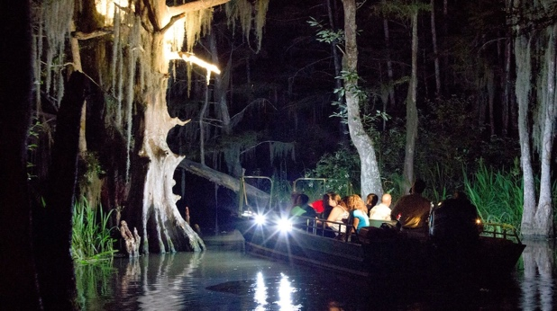
Honey Island Swamp Tour – at night!
7 days a week, 5PM $59
Forget the all the ghost and vampire business – nothing is quite as creepy as floating through the swamp as the sun sets and the wildlife comes out to play. Cajun Encounters is a proud member of the Louisiana Nature Conservancy, and works with a responsibility to protect the environment, providing an intimate look at the swamp without impacting the grasslands or the many diverse species of animals that call the swamp home: alligators, wild boar, raccoons, snakes, owls, egrets, and more – all in their natural habitat, and just a few feet from your boat!
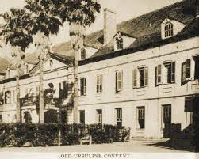
Old Ursuline Convent, 1100 Chartres Street
Museum – Thurs, Fri, Sat, Mon – 10am last admission 1:15pm
Built in 1727 and founded by the Ursuline nuns of Rouen, France. The convent served as a hospital and orphanage for young girls sent over from France by the King to the new colony, as future brides for the unruly, single frontiersmen who populated the wild city. Arriving in 1728, the poor girls disembarked at the port of New Orleans in the dead of night, pale and unwell after the journey that was supposed to take three months ended up taking five. They became known as the “casquette” girls, named so because of their pale, sickly condition and the little casket-shaped boxes they brought with them to carry their meager possessions. Folklore has it that’s not all the girls brought over with them from France. Arriving in the dead of night? Pale? Caskets? When the nuns quarantined the young girls on the third floor of the convent (supposedly even nailing the window shutters closed with nails blessed by the Pope!), word spread the “casquette” girls were actually….can you guess?? Vampires, of course!! Decedents of these girls live on in New Orleans today….

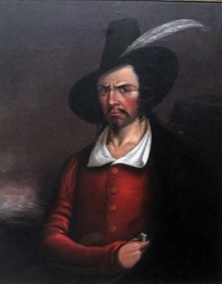
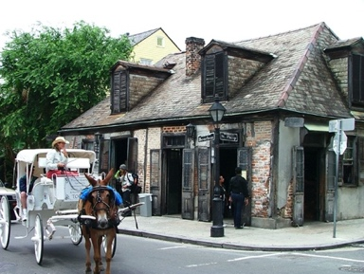
Lafitte’s Blacksmith Shop (bar) – 941 Bourbon Street
Open every day Noon til ??
Most likely built as a house in the 1770s during the Spanish colonial period, Lafitte’s is one of the oldest surviving structures in New Orleans. According to legend, French pirate, Jean Lafitte (1780 – 1823), owned a business here with his brother, Pierre, a blacksmith in the early 19th century. Together, they likely used the structure to plot illegal seizures and the sales of contraband. You know, pirate stuff! More recently, the café/bar became a popular night spot that attracted a bohemian clientele, including celebrities like Noël Coward and Tennessee Williams. It was declared a National Historic Landmark in 1970 and is said to be one of most haunted spots in the French Quarter.
Slow Your Roll
St. Charles Streetcar
Take it easy…catch the streetcar at the Common St. stop (off Canal) and let the iconic green trolly putt-putt you westward, through several NOLA neighborhoods. See the CBD (Central Business District), Warehouse/Arts District, Irish Channel, Garden District and Uptown, all from the comfort of your 150 year-old wooden bench. For $1.25 (exact change needed) you can sit back and enjoy the city as it rolls by. The grandeur of the historic Antebellum homes is not to be missed and if you’re lucky, you’ll catch the school kids playing their horns and drums as they walk to and from school. Magical. Get off at Tulane University and cross the street to visit Audubon Park for a stroll among the weeping willows OR hop off where St. Charles St. bends into S. Carrollton and treat yourself to a milkshake at the Camellia Grill. When you’re ready, hop back on the streetcar heading east toward Canal St., pay another $1.25 and see what you missed on the way up!

Off the Beaten Path…

Explore the Lower 9th Ward
You may have heard of this important neighborhood but unfortunately, possibly for all the wrong reasons. This section of the city was arguably the hardest hit in August of 2005, a.k.a. Katrina, and has been the slowest to recover. Deeply rich in culture but economically almost forgotten, the Lower 9th Ward (“lower” because it’s further down the Mississippi River and “ward” being an outdated name for voting precincts) has given New Orleans some of its most honored traditions and prized citizens including Fats Domino and Jon Batiste. Use this map as your guide and if you have time, make an appointment to stop into the museum, House of Dance and Feathers, located in the backyard of director and curator, Ronald Lewis. The museum is free and you’ll get a history lesson that is priceless.

Bike the Bywater
Ride along Crescent Park on the banks of the Mississippi River to this neighborhood (past the French Quarter, around the bend from the Marigny) that has become a “hipster” paradise pretty much since the Bacchanal Wine & Spirits (dubbed “NOLA’s backyard party”) opened just after the flood of 2005. Outdoor drinking, Mediterranean eats and live music every day make for a funky and relaxing way to spend a long afternoon.

